install

1. Download anaconda upload to chtc filefold
2. Run the following command
   * bash Anaconda**-**latest**-**Linux**-**x86_64**.**sh
3. Follow the prompts on the installer screens.
4. Say yes at last step

Install package

1. Set environment variable ,point to your anaconda3(or 2) / bin path everytime you login
   * export PATH=$(pwd)/.../anaconda3/bin:$PATH
2. Replace the “scipy” into the python package name you want

(nltk stopwords cannot use, define manually)

* + conda install scipy

1. create your own tarball of the installation:

going to your anaconda3 folder path

* + tar -czvf anacondas.tar.gz anaconda3/

.sh file

Your can get this .sh and .sub example at github/chtc folder

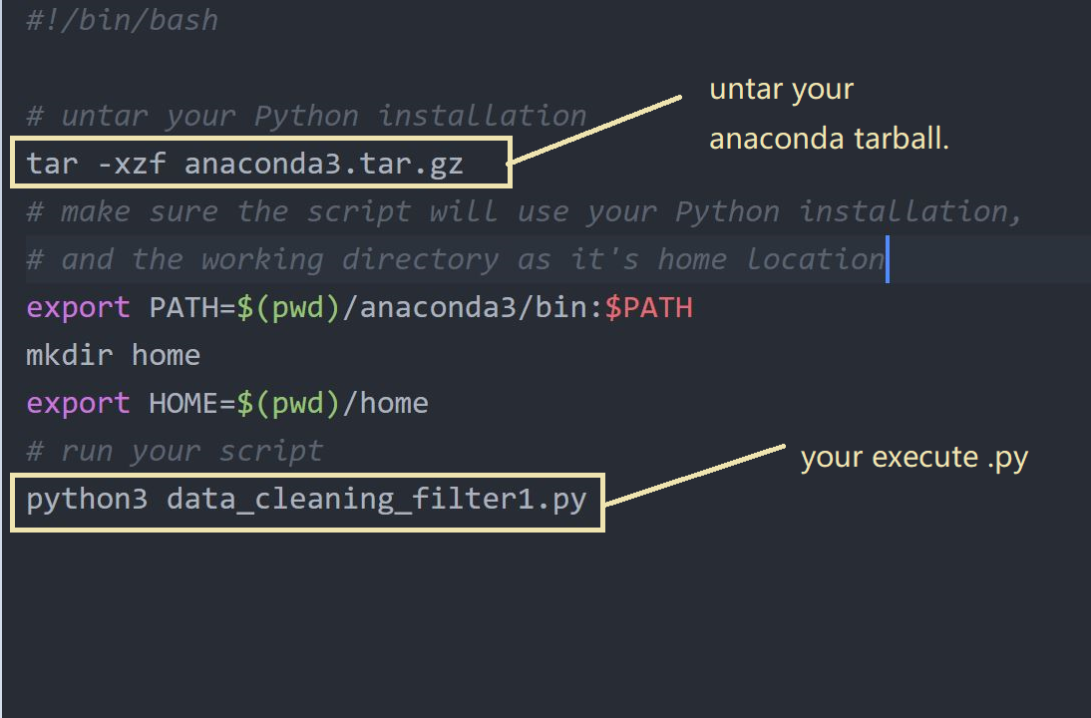

If you edit .sh at windows system…you need a little transfet

Run following at your .sh path

* + vi -b <name.sh>
  + dos2unix <name.sh>

.sub

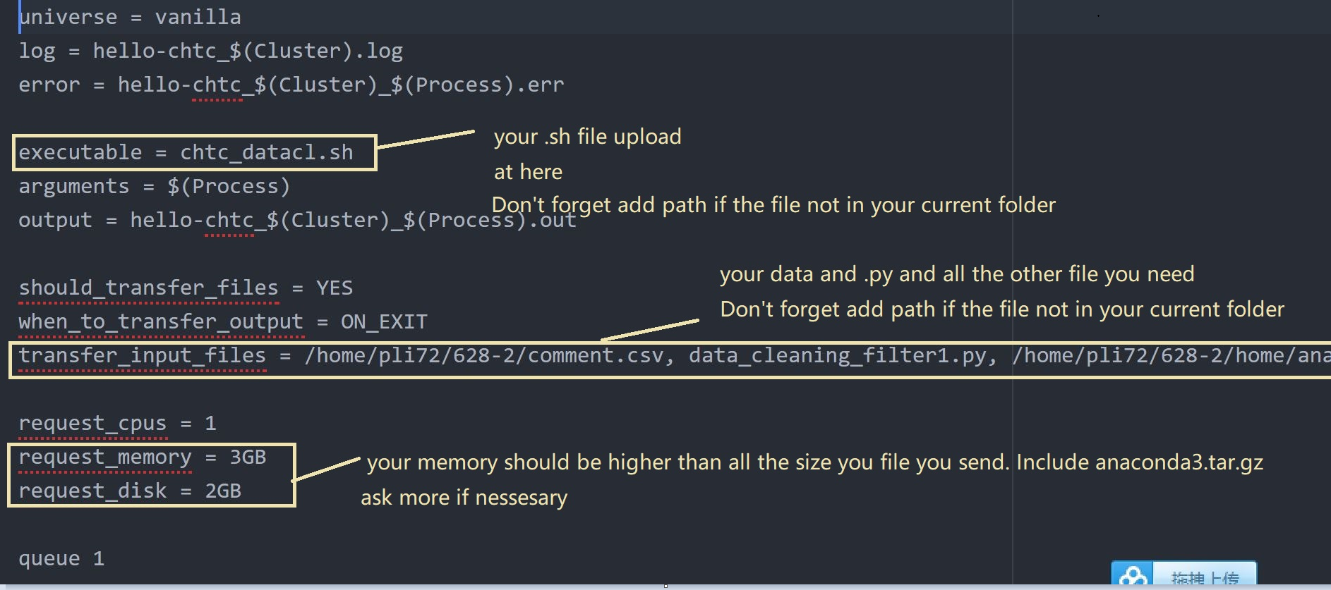

Check and rm job

* + condor_q
  + condor_rm <name>